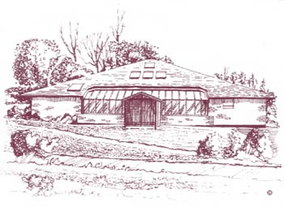

**Carmel Medical Practice**

**Patient Participation Group**

**Tuesday 24th September 2024**

**Present:**

**Sue Geldart – Practice Manager**

**Jennifer Smart – Deputy Practice Manager**

**Carole Ferguson – Patient Representative**

**Richard Twomey – Patient Representative**

**Jonathan Reay – Patient Representative**

**Joan Keating-Marjoral – Patient Representative**

**Chris McEwan – Darlington PCN Executive Board (LAY) Member**

|  |  |  |
| --- | --- | --- |
| **Item** | **Outcome** | **Action** |
|  |  |  |
| **Introduction and Apologies for Absence** | Welcome to Joan (first meeting) and Councillor McEwan.  No apologies received. |  |
| **Minutes from last meeting recap**  **Matters Arising** | SG discussed minutes from last meeting and asked if PPG would like anything adding or amending. No amendments, PPG minutes ratified and approved.  Councillor McEwan apologised for only being able to stay for 20 minutes but wanted the PPG to discuss the forming of a super PPG group covering all practices as all PPG's do things differently and we could learn from each other. Discussed this being annually and trying to include hard to reach groups. He also discussed the option of this being face to face, via teams or both. |  |
| **Practice Catchment Area**  **COVID/FLU/RSV Campaigns**  **Workforce Update**  **New Telephony System update**  **Complaints 2023/24**  **GP Patient Survey Results 2024** | SG discussed the Practice's catchment area and a housekeeping exercise recently undertaken to determine if any patients registered with the Practice reside outside the Practice's catchment area. The work identified a number of patients who reside outside the area who had moved and had not been deducted from the Practice list (areas such as Shildon, Newton Aycliffe, Bishop Auckland, Northallerton etc). These patients were contacted and deducted. The exercise also identified several other patients who reside (whilst in/local to Darlington) outside the Practice catchment area and the Practice wrote to those patients to let them know that they would be deducted if they were unable to confirm that they resided within the catchment area. A number of patients contacted the Practice to appeal this decision stating that they had been a patient for many years and asking the Practice to reconsider this decision. One patient contacted the press and following discussion with the ICB it was identified that some patients had been contacted who do reside within the Practice catchment area. This identified that the issue was that the catchment area map on the Practice website and the annual e-declaration submission was not consistent with the catchment area in the Practice's contract. Patients who had been contacted incorrectly (those that do reside in the contracted catchment area) were sent letters of apology confirming that, if they hadn't yet left the Practice or been removed, they would not be deduced. Those that had been deducted incorrectly or had left the Practice of their own accord (and reside within the contracted catchment area) since receipt of the initial letter were contacted, with an apology advising that should they wish to return to the Practice we would facilitate this quickly.  Those patients that had been identified as residing outside the contracted catchment area but had not appealed or left the Practice of their own accord were deducted. The patients who appealed (9) were discussed several times in Partners meetings to determine appropriate next steps. Another patient who had been deducted, who resides outside the contracted catchment area, submitted a formal complaint.  SG commented that this opened up a wider debate as several Practices in Darlington were working with catchment areas not consistent with the contracted catchment area (due to passage of time) and PMs met with colleagues from the ICB to discuss this further.  SG said her learning from this is to involve the ICB prior to such an exercise taking place and that the Practice need to more routinely deduct patients when they move address to one outside our catchment area. There are other areas we have not yet looked at but are confident that there will be more patients on our Practice list that reside outside our catchment area. One option is to register those patients as out of area registrations which has some limitations to services, such as home visits.  The Practice will not take on new patients who reside outside our catchment area and will be more robust in removing patients who move outside our catchment area. Whilst we cannot refuse a new registration for patients who reside within our catchment area, we will encourage patients to register with a Practice closer to them where there is another Practice(s) closer than us. As we have briefed PPG previously, the Practice list size continues to grow and there are more housing developments being built/planned. There is also the consideration of the time it takes to do home visits to patients that may live several miles away, which does impact our ability to see more patients in the same time.  PPG asked what happens now? Are we stricter? SG informed, yes, we are stricter with patients and do not register new patients if they live outside our catchment area and do explain to those wanting to register, who do reside within our catchment area, which Practice(s) are closer to them, should there be any, and encourage them to register at a Practice closer to them. We cannot decline new patient registrations if the patient resides in our catchment area. SG added that, if a patient moves out of the catchment area, they will be deducted. CM added this is becoming an issue as we are compact town, and the resources are under pressure but will have ongoing reviews. We need to consider Practice list sizes and ensure that all geographical areas are covered by at least one Practice. ICB suggested that we need to undertake wider piece of work to ensure all catchment areas are consistent with contract and determine if any Practices need to change them, the ICB requested that we do not deduct patients outside our catchment area until this work is concluded. SG added that we need to ensure that the catchment area on our website is consistent with our contractual catchment area. We can add a postcode checker so that patients can find out if they are in our catchment area prior to trying to register. SG added we have a number of patients that are registered with us but live closer to another/other Practice(s), example given of patients almost 5 miles away from this Practice and only 0.4 miles from another (have to drive past that Practice to get to us). The rules allow us to deduct patients outside our catchment area or to register them as an out of area patient, as discussed above, which has some restrictions on services they can access such as no home visits. If it became necessary for home visits then it would not be clinically appropriate or practical for these patients to be registered as out of area patients and they would need to register with a Practice closer to them, if they reside in that Practice's catchment area. PPG were supportive of the action taken to date and understand the rationale for this being undertaken, it is to ensure access to those patients who do reside within our catchment area, against backdrop of growing list size and the ability to undertake home visits for patients living outside our catchment area. As a Practice our building is only 45% of the size it should be for a list size of 10,800 and we are now at 11,480 registered patients and growing.  SG discussed 2024/25 campaigns with PPG. RSV (respiratory syncytial virus) vaccination is new and available for those 75- 80 years old before August 2025. Invitations for those eligible have been sent out and will continue after the start of the Covid/Flu campaign.  Covid and flu vaccinations will be available at the Practice from 3.10.24 and clinics have been planned and appointment links sent out to patients to book. SG informed we are planning vaccination clinics on the morning of Saturday 5.10.24.  SG/JS updated PPG on workforce and recruitment in the surgery.   * SG informed no changes to Partners or salaried GP. * No changes to Nurse Practitioners * Practice has 3rd GP trainee in Practice at present until February 2025 * Now have 4 Practice Nurses as we recruited replacement, and Nurse started June 2024 * Now have 3 HCAs in position as replacement HCA started May 2024. Another HCA has handed in her notice so she can undertake nurse training. We will go out to recruit asap. * First Contact Practitioner (FCP) DB is with us for 2 days per week, our aim was to have a full time FCP, but recruitment attempts were not successful. This was from ARRS funding allocated to the Practice. Feedback from PPG – lack of understanding of what a FCP does as comments from patients is that they do not complete any physio. SG informed the service is a triage service, 1st contact with advice and signposting. SG explained that GPs don't have direct referral route to Orthopaedics and have to go through MSK. Role of FCP is to see FCP instead of a GP to reduce demand from GPs. SG offered to ask DB to attend PPG to explain service, but PPG members felt this not necessary but more information to patients about the service and the role. * SG informed Partners had discussed using the ARRS funding for an Advanced Nurse Practitioner, but these now require a digital badge (takes 2 years for training and now a 1 year waiting list) and so as not to lose the ARRS funding we have recruited a Pharmacy Technician who starts 11/11/24 and will work will our Clinical Pharmacist. * JS informed we have a new Receptionist in team who started August 2024. * JS informed IT manager who is now back from maternity leave is changing role and moving to Data Entry Clerk position which involves record attaching, scanning, summarising, recalls and coding etc. We have advertised for a Compliance/Performance Administrator and had 10 applicants. Interviews will be week commencing 7/10/24.   JS updated PPG that call back functionality has been activated since the last meeting and staff and patient feedback is very positive. JS added that it has proved to be very beneficial early morning when the phonelines open, at the busiest times.  SG presented the complaints data for the Practice (see Appendix 1) and how the Practice learns from complaints and are used for training and reflection. Data for 23/24 presented compared to previous years, trends and themes. SG informed we now have a robust way of capturing complaint data, and we are more confident with the data submitted.  SG presented the GP Patient Survey results for 2024 (see Appendix 2) and the reasons for updating and sharing this with comparisons to previous years. SG discussed the results compared to the national average, ICS average and PCN (local) average and we have improved in all areas and compare better than ICS average, national average and PCN average (with the exception of website slightly lower than the PCN average). Website improvement was discussed and this, PPG felt, is better, SG added that further improvements can be made. PPG added that a well done is in order to the team as since SG started the results have improved. SG added her thanks and the team had been acknowledged and thanked by the Partners. | **SG to feedback to DB re patient information** |
| **Items from PPG Members** | * PPG asked if photos of staff were going to be displayed in Practice as aware of the expense of professional ones. SG informed to be discussed again. * PPG asked when a GP/NP cancel clinic due to illness etc can those patients who have had their appointments cancelled who may have waited for weeks to see a GP be given priority over others wanting appointments. JS explained we do try to arrange a replacement, if possible, for last minute staff illness and swap the patients to another clinician on the day if we have availability. SG added that we send an SMS to the early patients to cancel so they do not turn up at the Practice, but we could try to make a note and offer an appointment if possible. | **JS to discuss with CT/Reception that post cancellation, patients are contacted or asked to contact us, and we can prioritise getting new appointments arranged as soon as possible** |
| **Any Other Business** | SG discussed PPG super meeting following CM's introduction and initial question for their input, and all unsure how effective it will be and would it not be better to stick to own practice PPG. Unsure how effective a combined virtual and face to face meeting would work. All agreed would need more information and to understand the purpose and benefits before they could commit to attending another/wider PPG. | **SG to feedback PPG views to CM.** |
| **Date and Time of Next Meeting** | To be confirmed, PPG asked for the next meeting to be January 2025 | **JS to arrange** |

Appendix 1

Patient Complaints 2023/2024

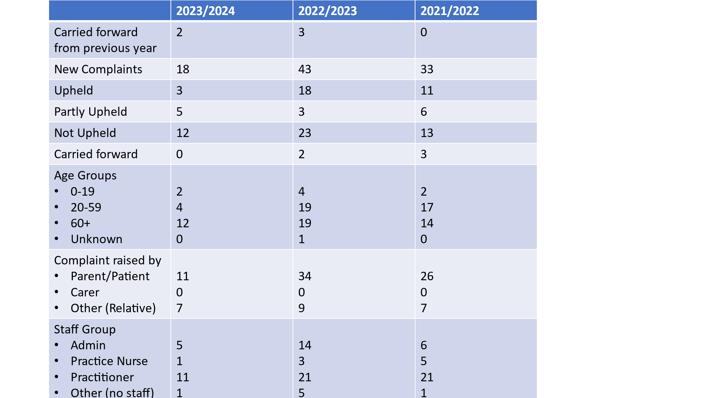

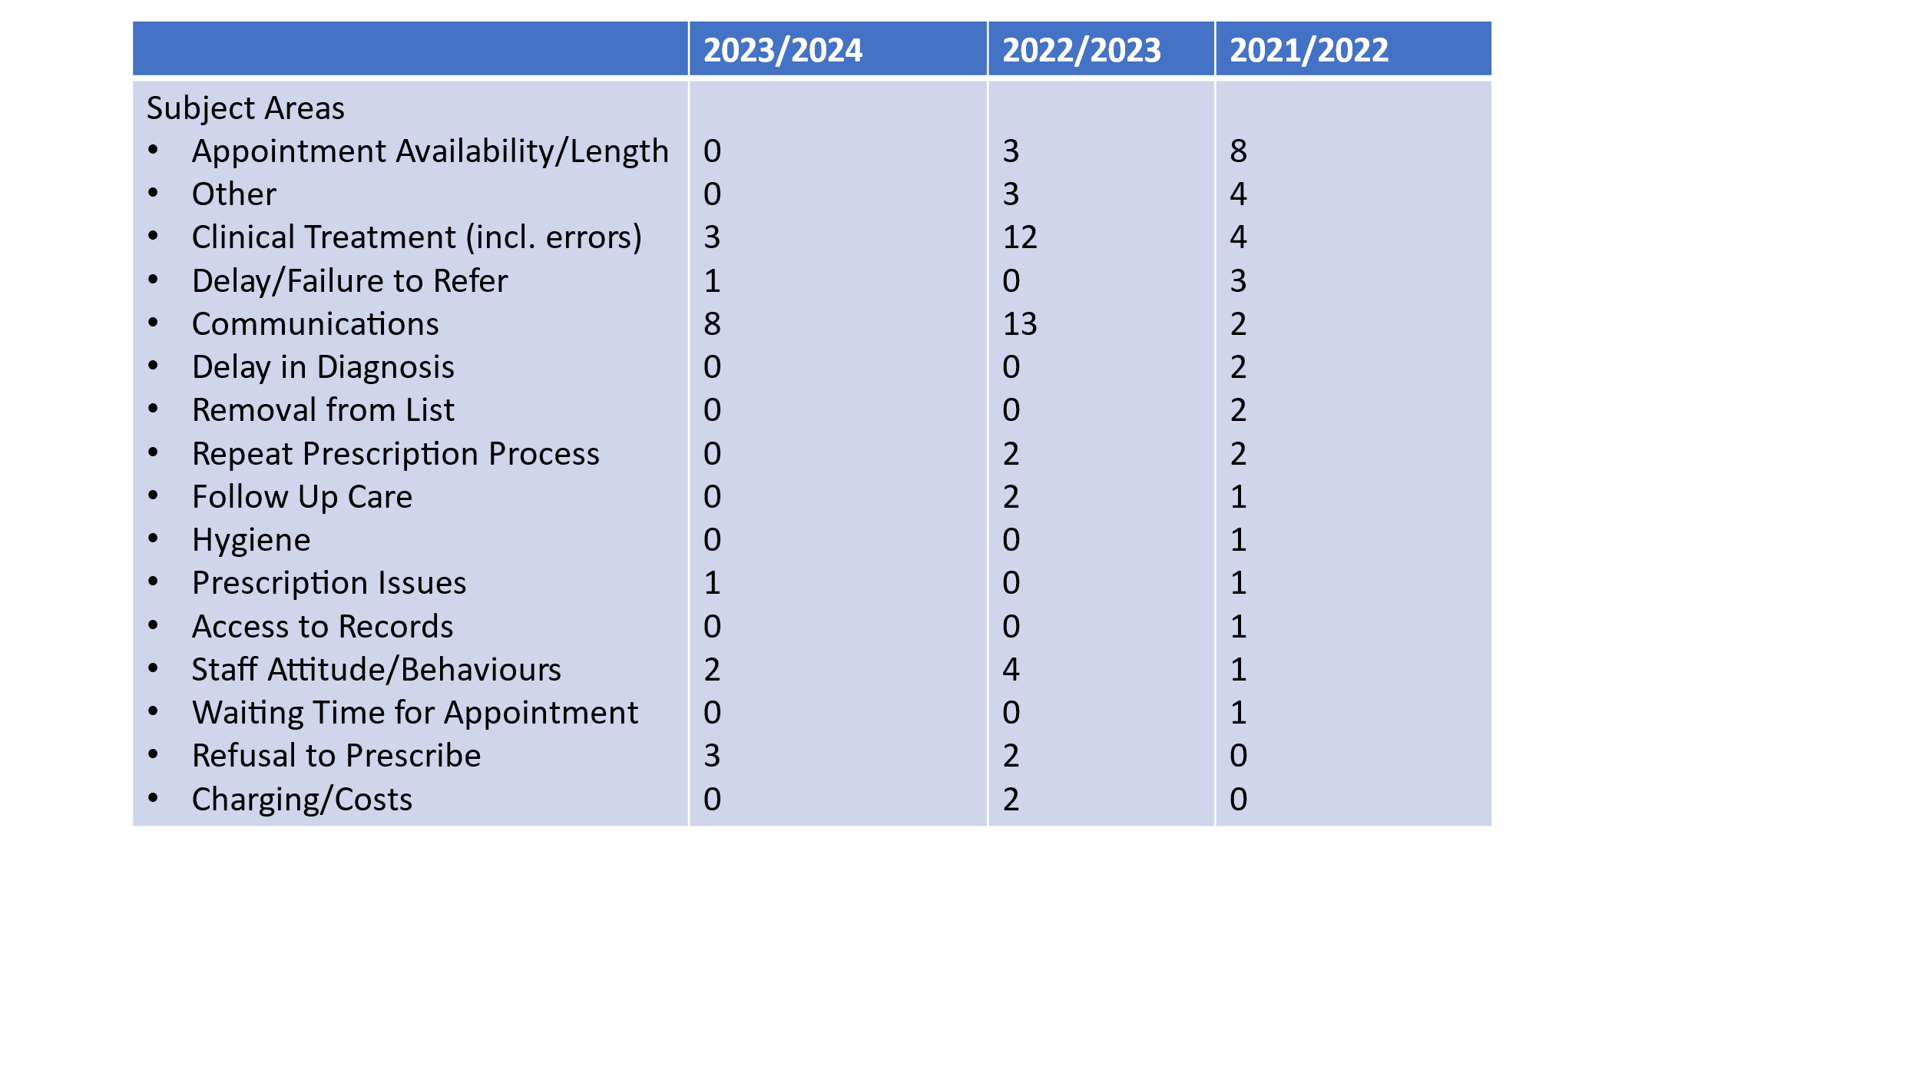

Appendix 2

National Patient GP Survey 2024 Results – Carmel Medical Practice

